Joseph Silva Jr.

10/15/2021

SNHU

IDS 403 Final Project Part 1

**Introduction:**

When it comes to a specific event or issue about a technology affecting the human race, there were many choices available to choose throughout history, whether it was creation of atomic bomb, space travel, development of the smartphone, access to the internet, etc. For my topic, I choice a technology closer to the modern age and it can be used as a steppingstone to unlock a type of tech with one of the highest potentials in changing the world. The development and public access of the Oculus Quest headset tools in May of 2019. The Oculus Quest headset is a tool to allow users to access a virtual reality system from anywhere with a Wi-Fi connection access, which now adays can be accessed anywhere in the world. Currently, Oculus has implemented its Quest 2 headset to handle augmentation reality, which I believe can be used later to change how activities are handled in daily life. As a society, we can learn how technologies like the Quest 2 can affect us by the use of the four general education lens which are the following: History, Humanities, Natural and Applied Science, and Social Science. Using these lenses, we can see how the Quest 2 can affect our present and future when it comes to our physical, mental, and emotional connection with our community and our reality.

**History Lens Connection:**

As our access to virtual and augmented reality continues to grow, we are gaining access to the metaverse and bringing aspects of the metaverse to reality. I have found many documents and videos explaining the metaverse. The easy way to compare these systems is gaining access to the metaverse using virtual reality would be like the movie “Ready Player One” and bringing aspects from the metaverse to reality would be like having access to a personalize “Jarvis” from the Ironman movies. In 2021, Facebook and other corporations are attempting to make a breakthrough into the metaverse. The business Oculus is a business under the corporate umbrella of Facebook and Facebook is using tools like Quest 2 to gain access to the metaverse. The actions of all these companies, which includes Facebook, coming together in 2021 to make many tools to gain access to the metaverse has created a digital frontier for users to create their own personal worlds within the digital universe. However, the continued push of a digital frontier might move humanity away from future reality discoveries such as further space travel, ocean travel, and inner earth travel.

**Humanities Lens Connection:**

The Oculus Quest 2 has mostly been adopted by teenagers to young adults when it comes to the applications of video games being played in the virtual world at one’s home. We can see in many online video posts how younger adults are integrating older individuals such as my generations’ parents into these virtual reality video games. The Oculus Quest 2 gives users the ability to view the artwork of individuals creating the video games. Since their original creation, video games were always a work of art because it shows how CGI design, painting, coding, storytelling, and world development come together to create a world designed by the creators’ imagination. With the Oculus Quest 2, a user can enter the virtual world to become the main character of the video game, which allows the user to become one with the artwork. The access to the virtual world allows individuals to see the beauty and dedication to the design of a new world with the user’s own eyes.

**Natural and Applied Science Lens Connection:**

As I previously stated, the Oculus Quest 2 allows users to see how all the coding, storytelling, design, etc. come together to create a new world. The Oculus Quest 2 is a device which uses Biology and Computer Science to give the user the best experience in the virtual world. Through videos on the internet, we can see how Biology of a human such as body movement, hand movement, and visual experience combine with how Computer Science uses coding to develop 3D designs and the user’s actions affecting the virtual world. Besides the virtual world, the Quest 2 has now integrated the augmented reality to its system. With this integration, the Quest 2 will allow digital designs to be displayed in the real world and this will allow additional Natural Sciences to be applied with the combination of the digital and real world.

**Social Science Lens Connection:**

From a personal standpoint, I have seen virtual and augmented reality has the ability to connect groups of people from all across the world, exactly how a social media platform does at this current time. Using the Quest 2 with a massively multiplayer online-playing game, users can make connections through the metaverse by creating avatars and connecting with other avatars. I have also seen the opposite of gaming systems, such as PC or Quest 2, cause problems for individuals being able to adjust to the real social structure and be apart of a community due to their communication skills lacking. These lack of communication skills have caused issues because their social skills have not been practiced on a daily basis and it causes individuals, mostly teens and young adults, to be quiet and have poor communication skills.

**History Lens Analysis:**

The Oculus company was purchased by Facebook Technologies, LLC in 2014 for 2 billion dollars. The virtual reality device allowed Facebook to take it first steps in the pathway to enter the metaverse and many other big techs followed in order to have their part in creating the metaverse. These big techs state the metaverse is the future of the internet. The metaverse is a 3D universe which is created through the use of different realities such as virtual reality, augmented reality, extra reality, and mixed reality. These realities allow humanity and 3D internet designs to be combined to allow the user the ability to view and enter the metaverse.

In 2018, the general public got a glimpse of the metaverse through the sci-fi film “Ready Player One”. Ready Player One is about an “orphaned teenage hero flees his bleak real-world existence by immersing in a dazzling virtual reality fantasy. The boy straps on his headset, reminiscent of a pair of VR goggles, and escapes into a trippy virtual universe, dubbed OASIS. (4)” The equipment used by the main character in Ready Player One is a similar design to the Oculus Quest VR device, which was released in 2019 to the general public. The Oculus Quest 2 device was released by Facebook and the device allows virtual reality to be visualized and interacted with by users. Facebook went from a major social media platform to one of the first companies to enter the metaverse by using the Quest 2 and a Facebook social media account.

At first, the Quest 2’s user did not have to worry about having a Facebook account to access virtual reality, but the company has changed its mind by requesting each user to have an account by the year 2023. Facebook is going to be going all in to gain access to the metaverse with the use of Quest and it will register the users through their social media accounts. These open new possibilities by allowing a creation of a metaverse 3D market which can allow users to purchase items for the real world through cryptocurrency. Facebook is ready to lead society and other big techs into the metaverse with the help of their new CTO Andrew Bosworth, who is head of the AR/VR division of Facebook.

The creation of devices allows us to see an issue in society and it has been an issue for a long time. An individual desire to escape our own personal reality and leave behind the daily stress. The Quest 2 allows general users to leave a world filled with limitations and enter the digital frontier.

**Humanity Lens Analysis:**

The Oculus Quest 2 is one of the few gateways that allow individuals to enter a reality where the development of worlds and characters are only limited by one’s imagination. The development of devices like quest 2 has affected my personal life, but not my professional life. I can see my younger siblings avoid in-person society and they prefer contacting other individuals within the different realities accessibly by The Quest 2. The Quest 2 allows people to connect with each other, no matter the distance, through applications used by these devices. These applications give users the ability to see the beauty of other users’ culture by apps such as “The American Experience by Boulevard” (2) or to see the imagination of other users by the app “VRchat”. With VRchat, users can see virtual reality worlds created by programmers and they can see avatars created by other users. During my research, I found a YouTube video showing the top 10 VRchat avatar worlds (1) and these worlds are compatible with the Quest 2 device. The VRchat avatar worlds can be accessed by Quest 2 to allow users to meet up with other users by using created and modified avatars. These worlds allow the programmer to create new realities through visual arts and the Quest 2 allows the users to become a part of these visual art worlds. While watching the video, the two worlds I saw with the best artwork out of the 10 worlds were Jelly’s Random Avatar World and City 17. Please see the example below to see a distilled image of the Jelly’s Random Avatar World of a customized avatar.

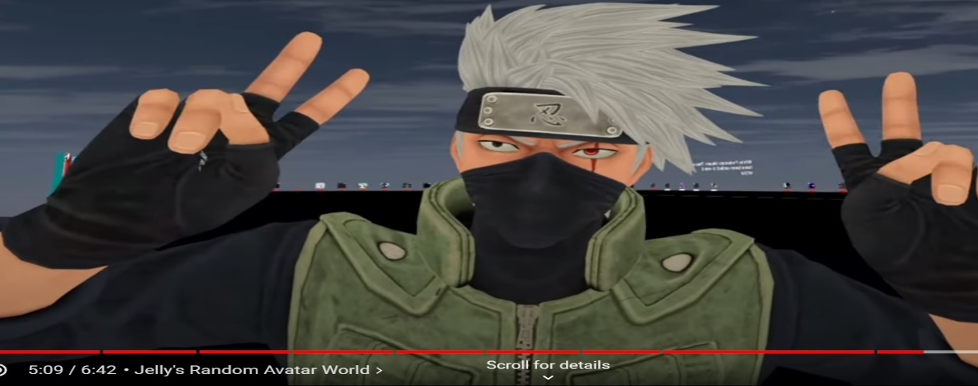 (1)

The ability to customize the avatars in these worlds allows any person, regardless of their programming or artist ability, to become a user and to create a character from the user’s imagination. I believe devices like Quest 2 give a message to society and the message is humanity will no longer be limited to only God’s imagination.

**Natural and Applied Sciences Lens Analysis:**

The natural and applied sciences are sciences such as biology, chemistry, physics, etc. When it comes to device such as the Oculus Quest 2 Virtual Reality, the video games use these sciences for the system, user interfaces, apps, and controls. We can see Biology and Physics be affected with the use of a Quest 2 system such as Guardian. Guardian uses video cameras and recording devices to create a virtual barrier to protect the user from crashing into the surrounding designs of the residence and showing a visual design for the user to be able to see. Please see the photo below of an example of the Guardian system.

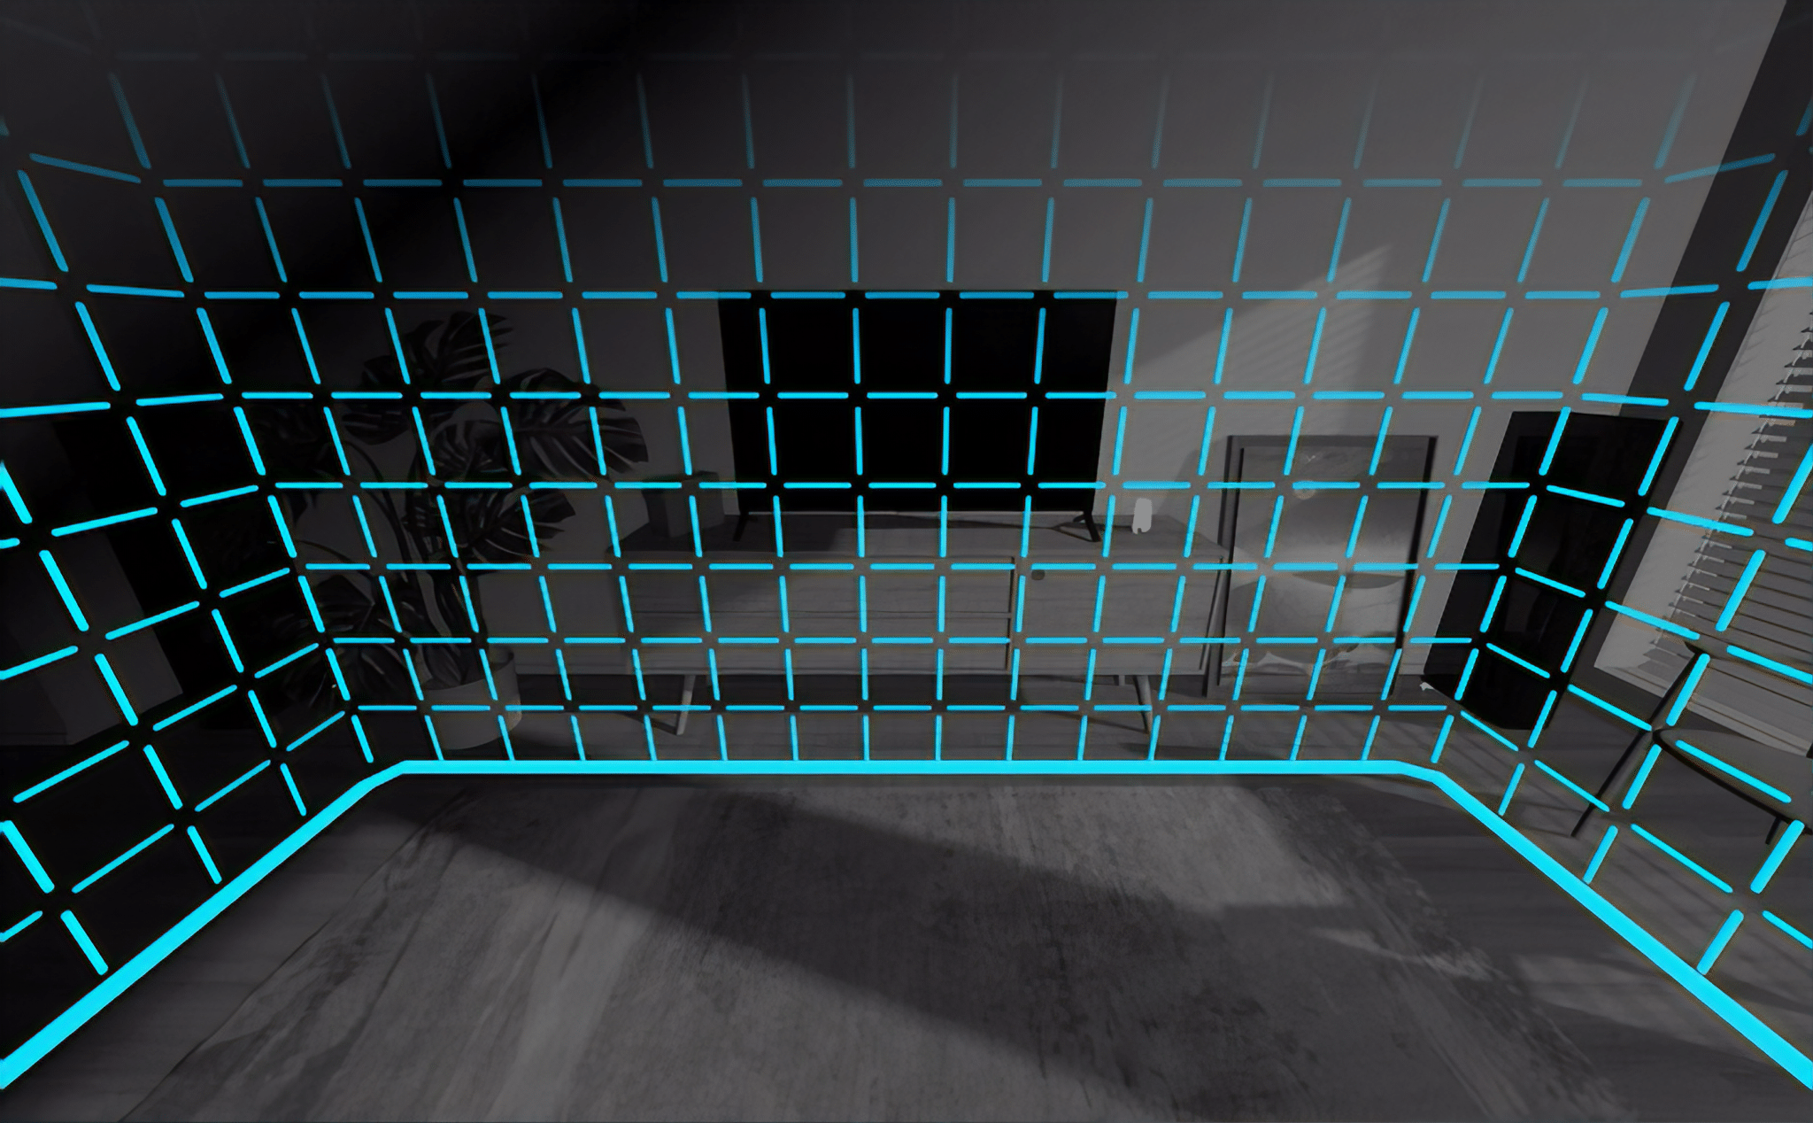

Overtime, these systems and apps that affect users’ senses can be used to help with many medical issues such as mental health conditions and sensory malfunctions. For example, these virtual reality devices use the metaverse to create training seminars and scenarios for doctors and patients. Doctors can use the metaverse to create scenarios for virtual surgery for practice without having any major issues.

**Social Sciences Lens Analysis:**

When it comes to Social Sciences, these are the sciences that affects the social connection with individuals from the same or different communities with one another. These virtual reality systems allow virtual communities to develop, and it allows different users to view other types of communities. These virtual realities allow the users to connection with each other on a deeper level than social media or regular gaming. Users can experience new visual experiences with one another, and these new experiences allow the users within the community to learn about other points of view from members of the same or different community. The Quest 2 device has implemented apps to allow users to learn about these different communities by experiencing many different cultures through virtual reality. Users can use apps such as the “American Experience” and “Mondly: Learn Language in VR” virtual reality apps to give tools to experience these cultures. Please see the photos below for examples of these apps.

**American Experience Mondly: Learn Language in VR**

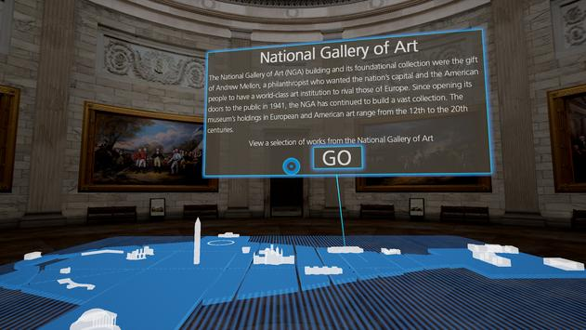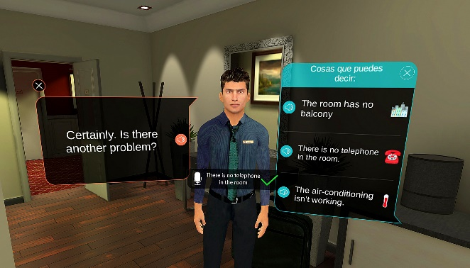

**CONCLUSION**

Within this paper, I was able to describe how the Quest 2 VR devices affects society by using the four lens to describe these affects. An individual can use these four lenses and the affects to see the Quest 2 allows individuals to connect with one another through new experiences whether it is a business meeting on Facebook Horizon or fight Darth Vader in a multiplayer game because users are able to interact with other users, which will allow users to evaluate each other’s cultures and skills. In the section above, I was able to show how users are able to connect with different cultures by having virtual tours of different countries history and by being able to learn different languages from a different way of teaching. These areas are just a few benefits devices like the Quest 2 give users in teaching and learning between each other to benefit society. Along with the benefits, the Quest 2 and other VR devices also have challenges within society such as major CEOs of companies like Elon Musk and Jeff Bezos bring attention to other technology and society pathway. These CEOs have a desire of space travel and space travel has gotten more media attention than big tech development of the metaverse. These areas in the technologies of the metaverse and VR devices, such as Quest 2, have and will affect society in many different ways. These will allow users in society to be able to express and connect with each other by connecting through the users’ imagination and technologies new way of communication.

**CITATION:**

1. YouTube. (2021). *YouTube*. Retrieved September 11, 2021, from https://www.youtube.com/watch?v=d5KzLgbb5Xo.
2. YouTube. (2021). *YouTube*. Retrieved September 26, 2021, from <https://www.youtube.com/watch?v=e_Y5y2X3YYc>.
3. *American experience by Boulevard on oculus go*. Oculus. (n.d.). Retrieved September 26, 2021, from https://www.oculus.com/experiences/go/1545812398780175/.
4. Newton, C. (2021, July 22). *Mark in the Metaverse*. Retrieved September 27, 2021, from <https://www.theverge.com/22588022/mark-zuckerberg-facebook-ceo-metaverse-interview>
5. Brown, D. (2021, September 1). *Big Tech wants to build the 'metaverse.' what on Earth does that mean?* The Washington Post. Retrieved September 27, 2021, from https://www.washingtonpost.com/technology/2021/08/30/what-is-the-metaverse/.
6. Cao, S. (2021, September 23). *Facebook enters 'metaverse' in full force as AR/VR chief takes over as CTO*. Observer. Retrieved September 27, 2021, from https://observer.com/2021/09/facebook-replaces-cto-andrew-bosworth-ar-vr-metaverse/.
7. *The Science of Virtual Reality*. The Franklin Institute. (2020, January 2). Retrieved October 9, 2021, from <https://www.fi.edu/virtual-reality/the-science-of-virtual-reality>.